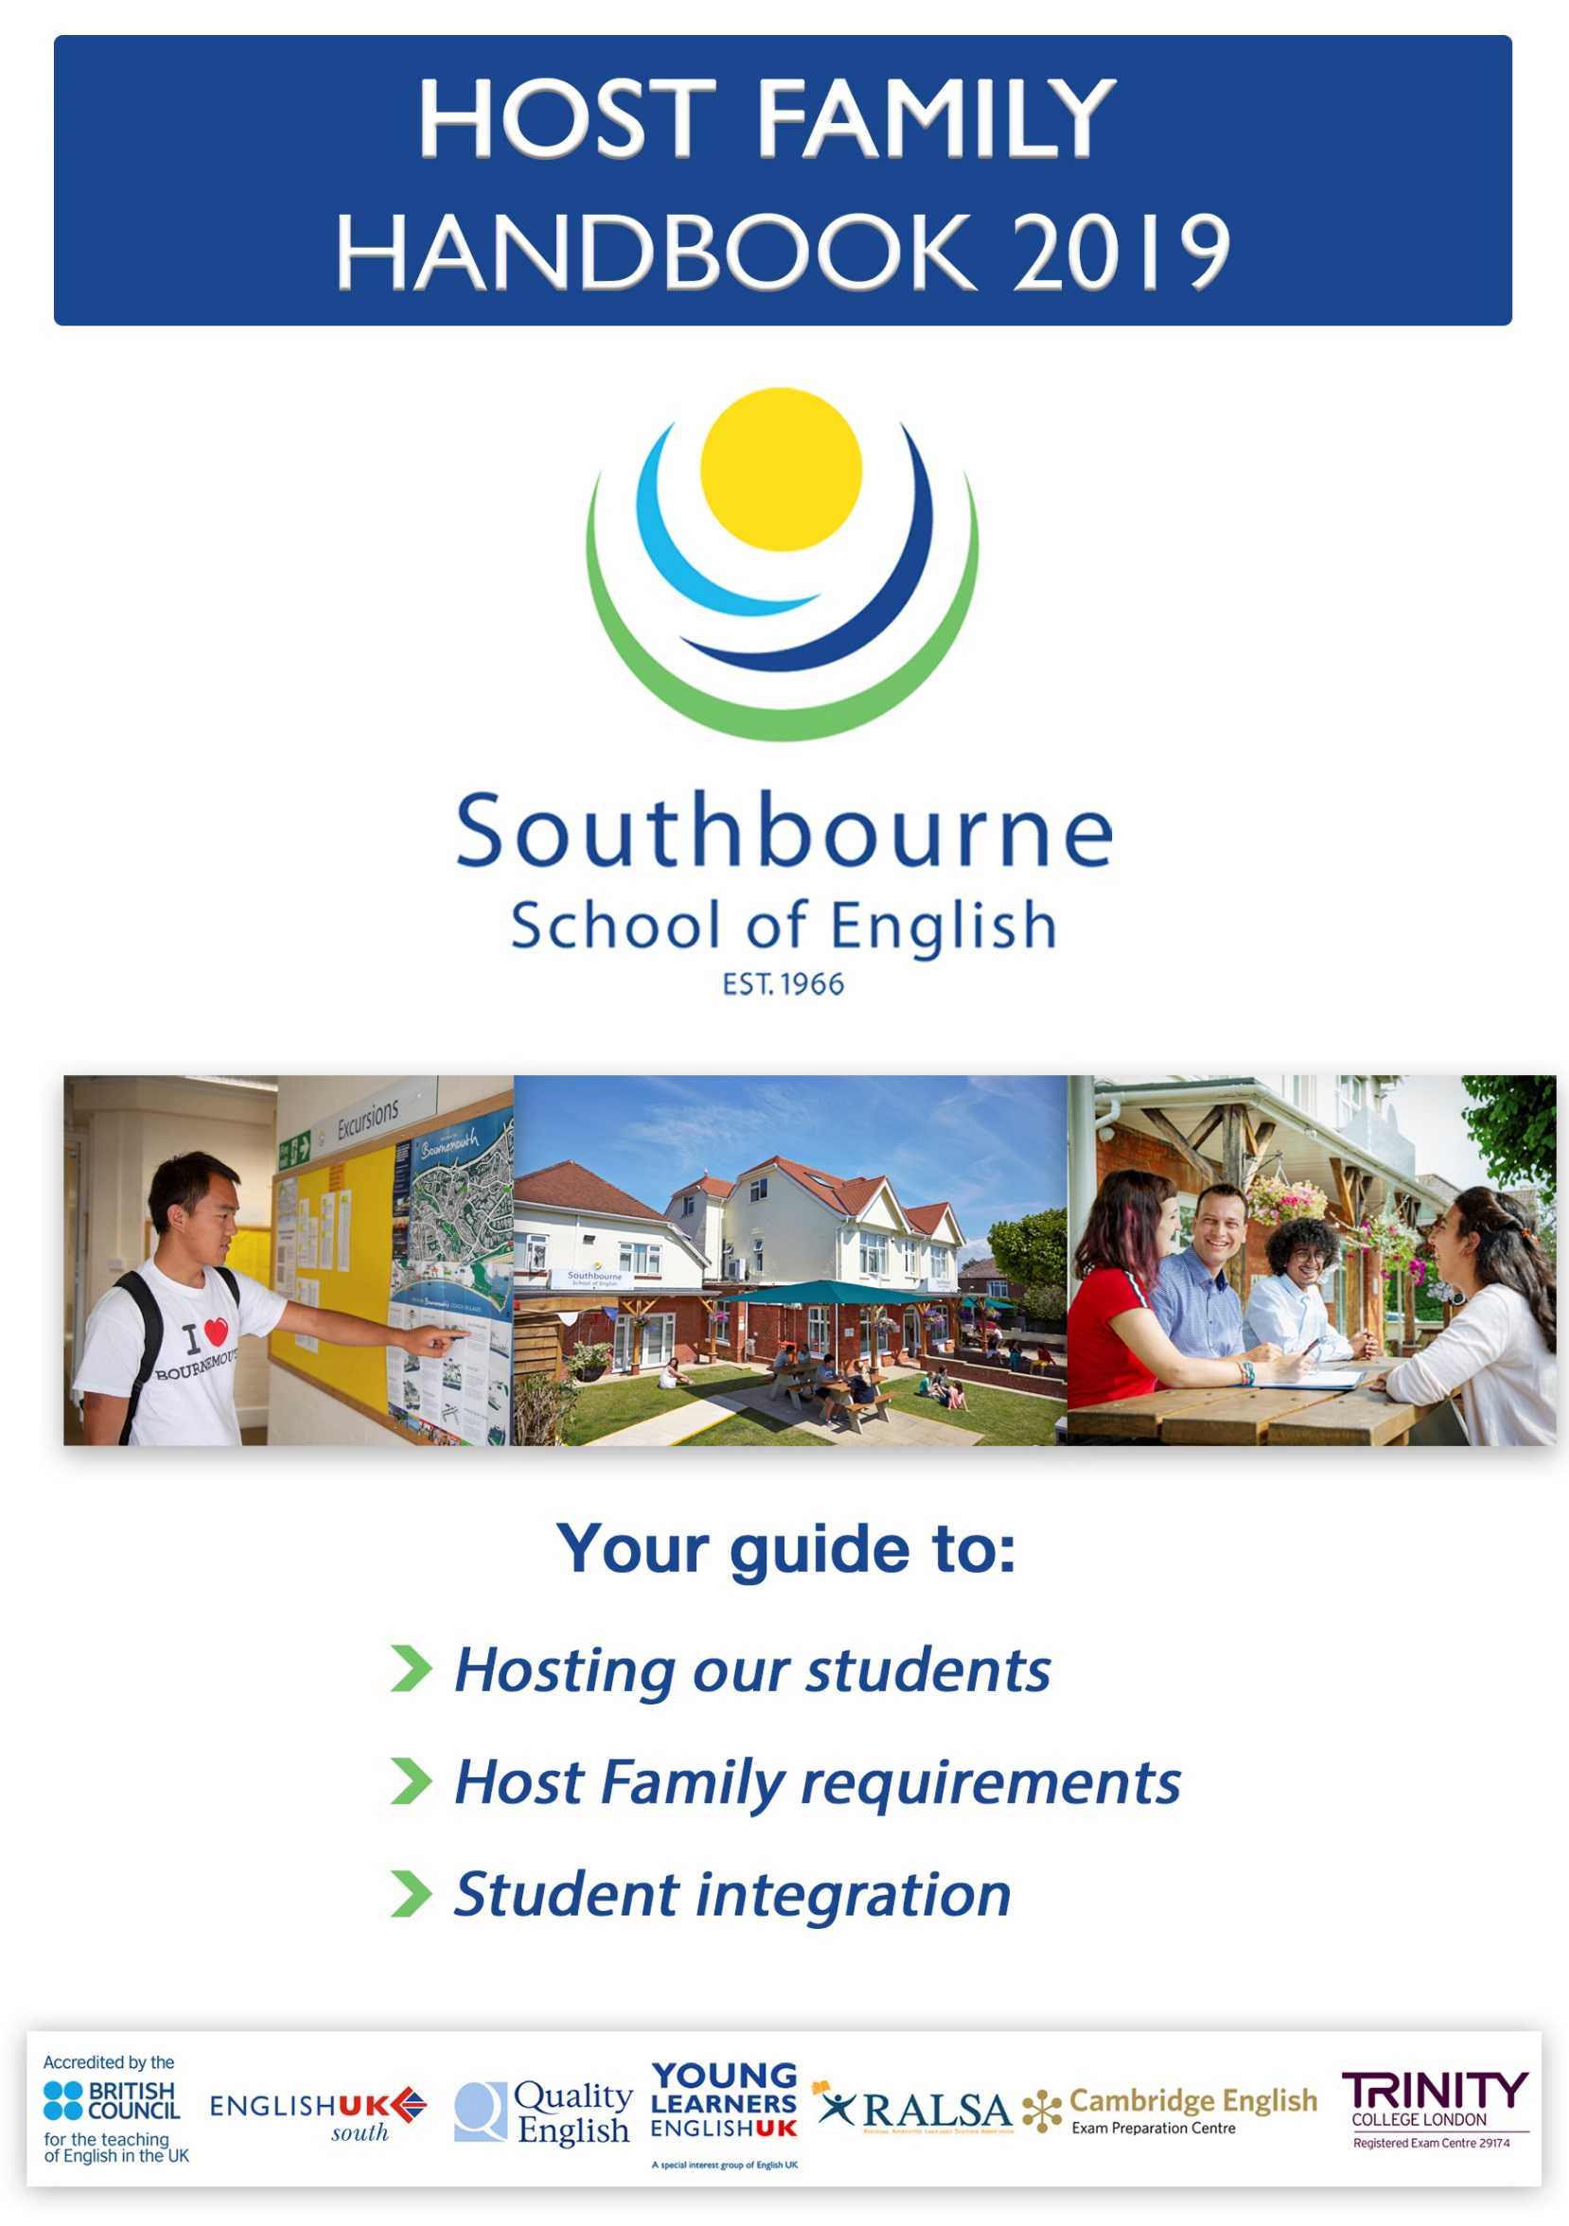

FREQUENTLY ASKED QUESTIONS

I DON’T KNOW WHAT TIME MY NEW STUDENT IS ARRIVING
Where we have arrival details we will email and text those 2 to 3 days before the student is due to arrive. Please do not use the emergency number for arrival details.
Times: Weekend arrivals/departures: Can be at any time of day
Weekday arrivals (Mon-Fri): No earlier than 5.30pm
Weekday departures (Mon-Fri): No later than 9.00am
Groups: Most of our groups arrive and depart by minibus/coach at the school and need to be picked up or dropped off by you. Any delays will be texted with new ETA if we have it.
Individuals: Individuals are usually dropped direct to your door or make their own way to you. We will inform as much as we can about the arrival times.

I DON’T UNDERSTAND HOW THE HOSTING PAYMENTS WORK
BACS payment is 2 weeks in arrears and 2 weeks in advance for weekend arrivals. This changes if a students arrives between Monday and Friday. See examples on page 7.

I NEED TO STAY AWAY FROM HOME OVERNIGHT
Please contact the Accommodation Office on 01202 422300. It is normally not acceptable for students to be left alone in your home overnight. Under 18s cannot be left alone.

MY STUDENT HAS LOST MY HOUSE KEY
It would be reasonable to ask your student to pay for a replacement key. We would advise that your address should NOT be attached to the house keys but that you put it on an identifiable keyring instead.

MY STUDENT OFTEN EATS OUT IN THE EVENING
On their arrival you should ask if your student has any food likes or dislikes, as this should encourage the student to eat with you. It may be that they are unsure of what they are eating and in some cases this may need explanation.
Please contact the Accommodation Office if this is cause for concern.

MY STUDENT WANTS TO COOK IN MY KITCHEN
This depends on your own house policy. Many students cook amazing food from their own country. Whatever your policy, please explain it to the student. We ask that students be allowed to make tea and coffee.

I DON’T THINK MY STUDENT UNDERSTANDS ME
Students who attend Southbourne School of English all have different levels of English. Where possible, speak slowly or in some cases write things down, as students can sometimes understand the written word rather than the spoken word. Many students are extremely nervous at first, but you should find in a short time that they are feeling more relaxed and will communicate more easily.

Welcome to the world of hosting. Hosting international students
in your home is hugely rewarding, fun and interesting.

To ensure you have a positive experience this handbook outlines some of the information you will need to be a great host and answers some of the questions you may have about hosting students from
Southbourne School of English.

Contents
HOSTING OVERVIEW 3
Student mix 3
Hosting our Students 3
Hosting under 18’s 4
Hosting over 18’s 4
Arrivals and departures 4
Timetables 4
Activity programmes 5
Payments/Rates 5
Emergencies and using the emergency phone 7
Sickness 7
Weekends | Bank Holidays 7
HOSTING REQUIREMENTS 8
Room and House Types 8
Cleanliness | Hygiene 8
Safe Environment 8
Laundry | Using the Bathroom 8
Meals 9
Communication with Group Leader’s, School and Students 9
Informing of lateness / absence / concerns 9
Swapping Phone Numbers 9
Cancellations, Changes or Moves 10
Money | Valuables 10
Computers | Wi-Fi 10
Breakages | Damages | Insurance 10
House Rules 11
Planner 11
MAKING STUDENT’S FEEL WELCOME – STUDENT INTEGRATION 12
DECLARATION 14

HOSTING OVERVIEW

Student mix
We welcome students from all over the world to Southbourne School of English and therefore have a broad mix of nationalities, ages and widely varying lengths of stay. Students as young as 10 years old and as old as 70 enrol at our school.
The school is open all year apart from two weeks over Christmas and bank holidays. Our busiest seasons are the Spring and Summer, particularly March/April and June to August. The course a student enrols on will determine how much time they spend at the school, how many activities they do and how busy they might be during the evenings and at weekends. Students come as individuals (on their own) or as part of groups (with several other students and usually a group leader).
All students walk to and from school each day on their own. For this reason our host families are all within a walking distance of up to 35 minutes from the school. Our younger junior students will always be placed as close to the school as possible.

Hosting our Students
We believe that a well-selected family is a vitally important factor in the success of a student’s stay in the UK. This is the most effective way for students to absorb the many English expressions, sayings and phrases that only occur naturally in the home environment.
In accordance with school/regulatory guidelines (Accreditation UK):
- You must not have more than 4 students staying with you at any one time. If you have under 18’s staying with you, you must not have over 18’s at the same time.
- We promise that there will be nobody of the same nationality or mother tongue staying in your home at the same time, unless specifically requested.
- We would appreciate your loyalty, but understand you may also have students from another school. If you do, please accommodate the students in a separate room.
- Please inform us of the age, gender and nationality of bookings taken with other schools so we can match the students we offer.
Occupancy guidelines:
Single (one student per room) | 18 years and over ALL YEAR  During LOW SEASON 16 + 17 year olds too
Twin (up to two students per room) | Up to 16 years old ALL YEAR  During HIGH SEASON 16 + 17 year olds too

Very occasionally we get a request for 3 or 4 students who want to share a room and in these instances we can use multi-bedded rooms if you have them. We cannot fill multi-bedded rooms with 3 or 4 students who have not explicitly asked to share.

Hosting under 18’s
- The main carer/host will need an enhanced DBS issued within the past 3 years. This is in accordance with our Safeguarding Policy.
- If you host 16-17 year olds we ask that you provide them with a key.
- Unsupervised curfews for under 18’s vary - our school policy is:
12 years and under | Not allowed out unsupervised
13-14 year olds | 9pm
15 year olds | 10pm
16-17 year olds | 11pm
This is unless the agent, parent or group leader has specified something different.

Hosting over 18’s
- Students over 18 years old need a room to themselves and don’t share unless they have asked specifically to.
- Over 18’s do not have a curfew set by the school.
- They should be given a key so they can come and go as they need to, within reason.

Arrivals and departures
- All arrival and departure dates are given by the school when the student is offered:
  - Groups and Individuals: Arrival times are sent via email and text 2 to 3 days before the student is due to arrive. This is so we give you the most accurate details.
  - Weekend arrivals/departures: Can be at any time of day
  - Weekday arrivals (Mon-Fri): No earlier than 5.30pm
  - Weekday departures (Mon-Fri): No later than 9.00am to fit around you
- Groups: Most of our groups arrive and depart by minibus/coach at the school and need to be picked up or dropped off by you. Any delays will be texted with new ETA if we have it.
- Individuals (those not part of a group): Individuals are usually dropped direct to your door or make their own way to you. We will inform you about the arrival times if we have them.
- If you have not heard from either the school or the student on the Friday morning before their arrival, please get in touch with us immediately as the school is closed over the weekend and calls are not picked up.
- On arrival we ask that you pick up students from the school with a car so their luggage can be taken to your home easily. We also ask host families to show students the route to walk to school before their first day.

Timetables
Southbourne School offers bespoke learning experiences for students:
- This means individuals, groups, juniors and seniors have a range of different types of program they can book with us.
- These will include different types and length of lessons that run at various times throughout the day.
- There are also different excursion packages for evenings and/or weekends.

Activity programmes
Low season (September to mid-June):
Groups: We will provide you with an activity programme. Changes are possible.
Individuals: Check what their plans are. They can sign up to excursions if they wish.

High season (mid-June to August):
Groups/individuals: We will send you a 10-week (junior or adult or both) activity programme prior to the start of high season. Changes are always possible, but not very likely. However, it depends on whether students sign up to optional evening activities and weekend excursions.

We try our best to inform you via text message (at least a day in advance) if junior students are going on optional activities or excursions. If they go out with their group leader and they’re walked home by him/her is the ONLY instance when the curfews (on previous page) do not apply.

Important facts during high season: Juniors are in school Monday to Friday from 08:45 to 17:30 and must attend the Saturday excursion unless it is their departure day.

Payments/Rates
Our rates and dates for 2019 are:
LOW SEASON  02.01.19 – 14.06.19  27.08.19 – 31.12.19 | HIGH SEASON  17.06.19 – 26.08.19 | XMAS SUPPLEMENT**  15.12.19 – 01.01.19
All students  (apart from privately fostered):  £111 per week | Students 16+ years:  £127.00 per week | All students:  £60.00 per week
Students 10-15 years:
£137.00 per week
Private Fostering  (juniors staying 26+ nights):  £126.00 per week | Private Fostering  (juniors staying 26+ nights):  £152.00 per week
Note: Payment amount does not differ by room type.
**Christmas supplement is a payment made on top of the weekly rate for any student who is staying with the family over the Christmas period.
Host family payments are made via BACS two weeks in advance and two weeks in arrears. Check on the next page examples, which will help you understand our payment system:

1 week booking (weekend arrival – Sat/Sun):
Arrival Departure
Sun, 7th Oct Sun, 14th Oct Sun, 21st Oct
Payslip sent 1 week payment
Thu, 18th Oct Tue, 23rd Oct

1 week booking (weekday arrival – Mon-Fri):
Arrival Departure
Tues, 9th Oct Sun, 14th Oct Sun, 21st Oct Sun, 28th Oct
Payslip sent 1 week payment
Thu, 25th Oct Tue, 30th Oct

2 week booking (weekend arrival – Sat/Sun):
Arrival 1st week Departure
Sun, 7th Oct Sun, 14th Oct Sun, 21st Oct
Payslip sent 2 week payment
Thu, 18th Oct Tue, 23rd Oct

2 week booking (weekday arrival – Mon-Fri):
Arrival 1st week Departure 3rd week
Tues, 9th Oct Sun, 14th Oct Sun, 21st Oct Sun, 28th Oct
Payslip sent 2 week payment
Thu, 25th Oct Tue, 30th Oct

4 week booking (weekend arrival – Sat/Sun):
Arrival 1st week 2nd week 3rd week 4th week
Sun, 7th Oct Sun, 14th Oct Sun, 21st Oct Sun, 28th Oct Sun, 4th Nov
Payslip sent 4 week payment
Thu, 18th Oct Tue, 23rd Oct

4 week booking (weekday arrival – Mon-Fri):
Arrival 1st week 2nd week 3rd week Departure
Tues, 9th Oct Sun, 14th Oct Sun, 21st Oct Sun, 28th Oct Sun, 4th Nov
Payslip sent 4 week payment
Thu, 25th Oct Tue, 30th Oct

Emergencies and using the emergency phone
- In the case of an emergency out of school hours (8.30am-5.30pm) please use the emergency phone number (07767 201301).
- On this phone you can leave a message which will be picked up by an on-call member of staff. If your message is a genuine emergency someone will get back to you with a response as quickly as they can.
- Emails are not checked out of office hours and, therefore, will not be read until Monday.
Please do NOT use this number for queries regarding weekend excursions, student timetables or school timings.
Extra information: If your student has come as part of a group, they usually have a group leader. This person is the assigned responsible adult for the group, staying locally and will have a contact number so that host families can contact them.
Group leaders are able to speak the student’s mother tongue and their English is usually good. Their mobile phone numbers are sent to you where possible on the student’s first school day.

Sickness
If your student is sick and needs to stay off school:
- We ask that the host family (of under 18’s) or students (18+) inform the school or the group leader as early as possible.
- Sick juniors under 16 should not be left unaccompanied at home.
- For contagious viruses such as Norovirus we ask students to stay away from school for 48 hours after they were last sick or had diarrhoea to avoid infecting anybody else.

Weekends | Bank Holidays
At the weekend your student may have planned activities, either through the school or that they have arranged for themselves.
If they have no activities planned, part of the responsibility of hosts is that students are included with the family’s general weekend activities. This extends to bank holidays.
On no account should students be told to vacate the home over the weekend or a bank holiday unless it is their wish.
IMPORTANT INFORMATION

HIGH SEASON (2019) 17th June – 26th August
LOW SEASON (2019) 2nd January – 14th June and 27th August – 31st December
XMAS SUPPLEMENT (2019) 15th December – 1st January

ADULT STUDENTS – 16+ years. 15 or 21 hours tuition a week. 16 or 17 year olds are minors under UK law. Additional curfews and waivers are required from their parents.

JUNIOR STUDENTS – 10-15 years. 15 hours tuition a week. Juniors are minors under UK law and subject to curfews and safeguarding. Can have school or group organised activities.

HOSTING REQUIREMENTS

Room and House Types
The school does not pay a different rate for different types of room or home. We have hosts with many different types of rooms, houses and configurations.
If you change one of your hosting rooms or undergo home renovations, please keep the school informed. The more accurate the information is that we have about your home and rooms, the better we can match you to potential student bookings.
We require student’s bedrooms to have:
- a proper full size bed (no sofa beds, blow up mattresses or futons)
- some storage (either a chest of draws or a wardrobe and hangers)
- a desk and chair
- Wi-Fi
There is no requirement for a TV in the student’s bedroom

Cleanliness | Hygiene
Host properties need to meet a good level of cleanliness, general repair and hygiene.
We reserve the right to withdraw hosts from our books or move students if we feel that this standard has not been met or maintained.
As well as first visiting your home when you become a host family we also regularly re-visit host families to check facilities and standards.

Safe Environment
The school has a duty of care to our students and host properties should be free from hazards and be a safe and secure place for students to stay.
We require:
- A copy of an up-to-date gas safety certificate
- That fire/smoke alarms and carbon monoxide detectors are fitted and regularly tested
- That there is hot water available at all times
- That there is heating during the colder months

Laundry | Using the Bathroom
A reasonable amount of light laundry should be included in your service to the students at no extra cost. Bed linen and towels are to be provided by the host family and changed once a week.
A bath or shower should be available to students staying in your home to use every day. Please talk with them regarding what time of day is best if they share the bathroom with your family.

Meals
Student bookings are on a part board basis, which means:
- That breakfast and dinner are provided by the host family.
- At the weekend this also includes lunch.
We ask that:
- The evening meal is eaten together and students are included in this as part of your family.
- They should not be given different food unless specific dietary requirements have been requested.
At the weekend students require a packed lunch if they are going on trips. If they are staying at home over the weekend, they will require a light lunch with you, again, as part of your family.
Students appreciate fixed meal times, however, please be aware that on occasion a school activity may interfere with these times. In this instance the student should let you know in advance and a cold plate or meal can be left to heat and eat on their return.
If a student has special dietary requirements, we always try to inform you of these before you accept the booking. Sometimes students do not tell the school in advance so it is always advisable to ask students when they arrive if they have any additional requirements you need to be aware of.

Communication with Group Leader’s, School and Students
This handbook should answer a lot of your questions, however, if you have any specific queries regarding a student staying with you, their timetable, activities or health, you can contact the group leader in the first instance. They should have the most detailed and accurate information regarding your student.
If they are an individual, you can contact the school to speak with someone who can help.

Informing of lateness / absence / concerns
It is your responsibility to care for students as you would your own family.
Please inform the school if you have a student with you who is sick and will not be attending school. If a student under 16 cannot come to school, they must not be left at home unaccompanied.
If your student needs to go to the doctor, they can register with your own GP as a temporary resident to seek medical attention. The Welfare Officer at school is there to help with any concerns over health or wellbeing.

Swapping Phone Numbers
Please exchange phone numbers with students on the first day they arrive, before they go out.
Please test the numbers to make sure they work and have been taken down correctly! It’s surprising how much this will help make a student’s stay smoother from the first day.
If the student has the group leader’s mobile number, please also save this. The school will send this to you, but this may be a few days after arrival so always check whether the student has it first.

Cancellations, Changes or Moves
- If the host family cancels:
Please inform the school as early as possible if you need to cancel a student booking.
- If the student cancels/changes:
We will inform host families as soon as we receive notification of a student cancellation or a change to their booking.
In some instances this may result in the student needing to be cancelled or moved elsewhere.
- If the student wants to move once they are here
Sometimes a student will ask the school if they can move host family. Once we have assessed the reason for this we may agree that moving the student is necessary.
If you have already received payment in advance for a period that the student is now NOT staying with you, this payment will be rebalanced with your next booking.
- If the host wants a student to move once they are here
Please keep in contact with us if you are experiencing problems with your students.
Most issues can be resolved with communication and support from school, however, in the event that you would like a student to be moved we ask that you give us fair warning and appreciate that at busy times this may not be possible immediately.
In all circumstances you will be paid for the number of nights the student actually stayed with you.

Money | Valuables
On no account should you lend students money.
Please encourage students to take care of their valuables and not to go out with large amounts of money (The school provides a safe in which students can keep pocket money, passports and tickets).
Should your student run out of money, please contact the Accounts Officer at the school immediately.

Computers | Wi-Fi
Most students have smart phones or tablets that they bring with them. We advise you to not let students use your personal computer.
Please let students use your home Wi-Fi, within reason, as they will often use this as a means of communicating with home.

Breakages | Damages | Insurance
The school is not responsible for any breakages or damages caused by a student.
You must arrange adequate insurance protection to cover accidental damage. Any compensation should be agreed between the student and the host family directly while they are here.

House Rules
It is a good idea for host families to produce a sheet of ‘family guidelines’ that can be available to the student in their room.
This is especially useful for students who have little English or a very different culture from ours as they can translate and digest it better. This notice could clarify things such as:
- Meal times
- Wi-Fi password
- Smoking rules
- Phone numbers
- Times to respect quiet
- Where to put laundry and how often it will be washed
- Using the bathroom (what is a good time to use the bathroom and for how long)
- Using the kitchen (kettle, microwave or fridge for personal use)
- How to lock the house or set alarms

Planner
We advise having a wall planner or diary to keep track of student bookings (see example below).
It can be a great help to have an overview especially during the high season.

 |  | January 2019
 |  | Room 1 | Room 2
… | …
Saturday | 5th | Arrival (Group):  Fabian, 15, German
Sunday | 6th |  | Arrival (Individual):  Jorge, 14, Spain
Monday | 7th
Tuesday | 8th
Wednesday | 9th
Thursday | 10th |  | Vegetarian
Friday | 11th
Saturday | 12th | Departure:  Fabian, 15, German
Sunday | 13th
… | …
… | …
Sunday | 20th |  | Departure:  Jorge, 14, Spain

MAKING STUDENT’S FEEL WELCOME – STUDENT INTEGRATION
Finally, here are a few tips or things to consider to help your students get the most out of their stay with you:
- Include students in family activities where possible; days out, BBQs, picnics or takeaways, board games, family sports etc.
- Try to cook a ‘traditional’ roast dinner or cooked breakfast at least once during their stay at the weekend
- If you are up for it - let the students cook a traditional meal for you!
- Encourage students to come out of their bedroom. Initiate playing a game or watching a film (with sub-titles if needed) together.
- Don’t panic if your student’s English level is low, this is why they are here. Use pictures, miming or simply showing them objects (e.g. a clock, a key or washing machine) to help them understand what you mean. Use translation apps as a last resort
- Don’t assume that practices that are normal to us are normal to them. Things that are commonly different include:
  - Ways of locking doors
  - The way plug sockets work
  - Our taps, showers and door handles
  - Using toasters/kettles – which many countries do not have
  - Using the toilet (sitting/squatting)
  - Putting paper down the toilet…
If you have any concerns talk to the student directly, following this, the school is here to help.
- It may seem obvious but many students do not understand many of our everyday customs. Saying ‘please’, ‘thank you’ and ‘pardon’ is second nature to us, but for most students it is not automatic. Similarly, queueing, is unheard of in many countries. Please do not think they are impolite – they just need to be introduced to it.
- Every student is different. This is the beauty of hosting. While different nationalities have different personality traits, all students have their own distinct personalities, too, and no two students are ever the same – enjoy the diversity!

DECLARATION

Thank you for reading our Handbook. This is your guide to keep and refer to.

Please sign the slip below, remove and return it to us to confirm you have read, understood and agree with the requirements to host for Southbourne School of English.

Name (PRINTED): _________________________________________________

Signed: _________________________________________________

Address: _________________________________________________

Date: _________________________________________________

Please email it to accommodation@southbourneschool.co.uk or return it by post.
Should you need a replacement copy please contact the school. We endeavour to help and support you in any way we can so please contact us if you have a query.

Kind Regards
Southbourne School of English

